Best Communications Inc
B.C.T
Taiwan Headquarters: 11Fl, Block. B, No.563 Gong China Factories: No.4, 3th Industrial Zone, Shang,
Zheng Road Luo- Dong 265 Yi-Lan Taiwan Sha, Village, Chang-An, Dong Guan China
+886-3961-6581.tel /+886-3961-4477.Fax +86-769-8541-9868.Tel
bestc@livemail.tw / d.wu-bestc@livemail.tw +86-769-8552-2839.Fax

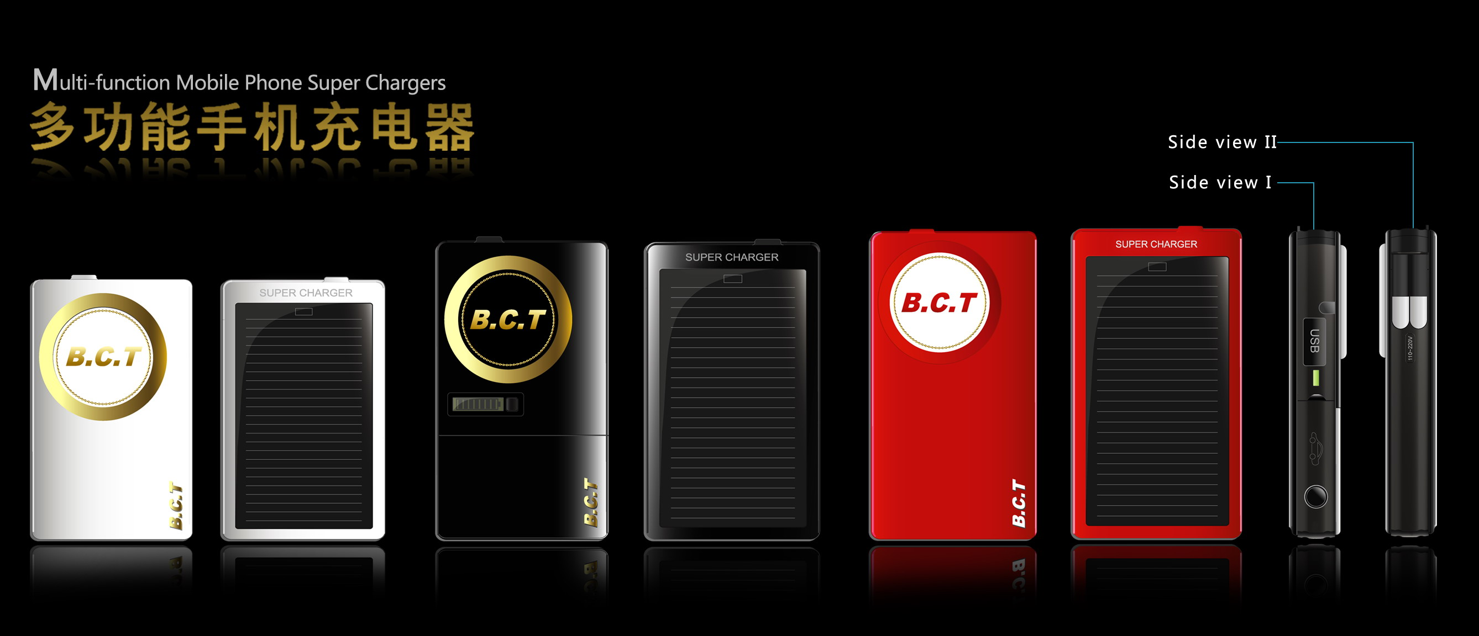

Mobile Phone Super Charger:
1.Solar power storage (single)
2.Application of built-in battery(capacity of battery :1000MA)
3.Charging via vehicle
4.Exchang for connection can charge for various mobile telephone(standard configure :five built in connections for mobile of Sumsung, Nokia, Motorola, LG and Sony Ericsson)
5.Through USB, The device can charging for digital products
6.CE, ROHS,3C Certifications Approval.
7. One USB outputs for simultaneous device charging includes USB charging cable for even lighter travel
Small and lightweight - fits in your pocket. Includes foldable wall blades and D.C power adapter(USA and EU Type) that easily store away. Works with multiple devices, including mobile phones, Bluetooth headsets, smartphones/PDAs, MP3 players, portable gaming devices, digital cameras, GPS devices and more. No need to buy a new charger when upgrading your devices; compatible with the latest models. Works worldwide; no need for a voltage converter when traveling
Notebook Super Charger 007-A
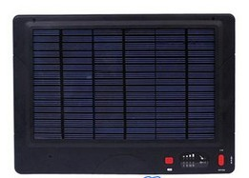

1.Charging via alternating current
2.Solar power storage
(191.4mm*279.6mm,single)
Solar panels power:4.5W
(The conversion rate of Germany silicon cells is 17% )
3.Charging via vehicle
4.Exchang for connection can charge for various notebook (standard configure :8 built in connections)
5.Through USB, The device can charging for digital products(notebook, mobile, digital products,PDA/GPS,MP3,Digital cameras and so on)(8 built in connections for mobile)
6.Application of built-in battery:3.7v
capacity of battery :54000MA

Notebook Super Charger 007-B
