 | 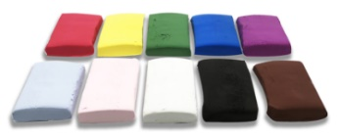 | 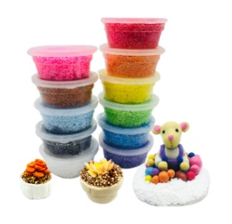 | 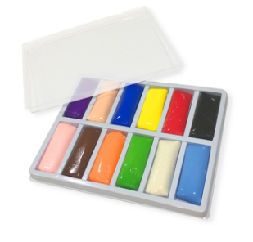 | 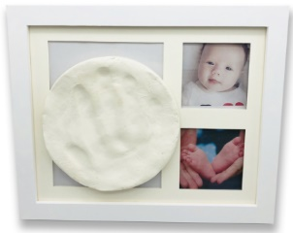 | 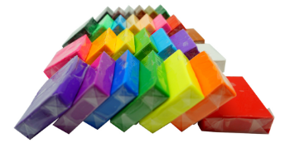
Name | Soft Clay | Foam Clay | Resin Clay | Handprint Clay | Polymer Clay
Features | Ultra light, smooth, air dry | No mess, contain styrofoam ball | Bright, silky,  Air dry | Create a lifetime keepsake to cherish | Soft, Pliable,  easy to shape
Material | Water based | Water based | Water based | Water based | PVC
Dry Time (according to finished clay thickness) | 12-24hr | 24hr | - days | 1-2 days | Oven Bake
Shelf life(unopened) | 1 Year | 3-4 months | 3-4 months | 1 Year | No deadline
 | 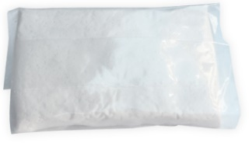 | 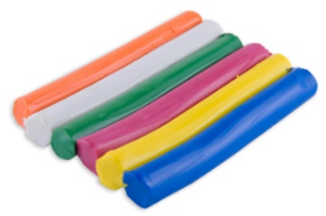 | 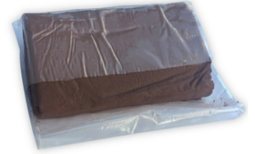 | 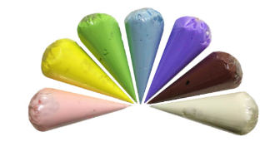 | 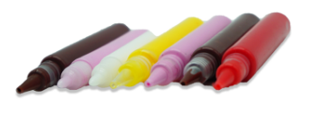
Name | Air Dry Clay | Oil Modeling Clay | Wood Clay | Cream Clay | Fake Deco Sauce
Features | Air dry, easy to paint | Reusable | Wood flavor, easy to shape, stickable | Looks like a real whipped cream | Stringy liquid, good for mini pieces
Material | Water based | Oil based | Water based | Water based | Water based
Dry Time (according to finished clay thickness) | 24hr | 1-2days | 1-2days | 1-2days | 1-3hr
Shelf life(unopened) | 1 Year | No deadline | 3-4 months | 1 Year | 1 Year
Notice:
- While opened, putting the clay into re-sealable plastic bags and boxes can keep your clay moist and soft.
- Temperature and humidity will affect the condition of clay, be sure to storage the clay in cool place to avoid exposure under the sun light.
- All of our products are non-toxic.

