Product Information

1. Description
Thermometer & hygrometer is a measurement device using USB port to connect to a computer . It can measure the temperature and the humidity of the machine and the environment accurately and can calculate the dewpoint automatable. It must be connect to the computer to start working .It can be use in computer room, weather, environment and special environment temperature and humidity testing.
2. Packing specification
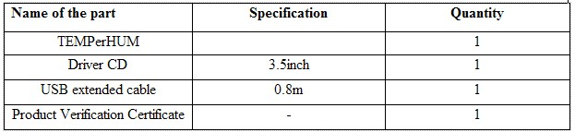
(Weight of TEMPerHUM: 60g)
2. Product photos
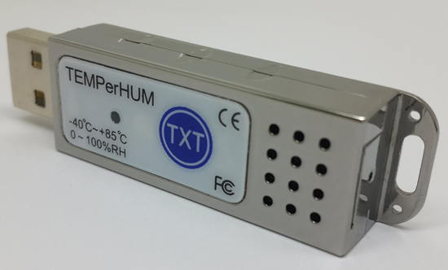
TEMPerHUM
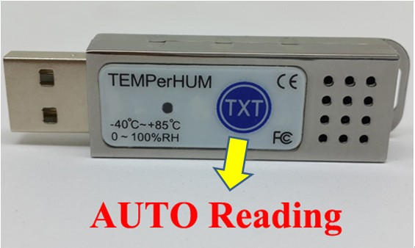
TEMPerHUM

3. Function & Feature
3. Function & Feature
Range of temperature: TEMPerHUM -40~+85 C; -40~+185F;
Resolution rate of temperature: 0.06C
Temperature senosr :
(1) +/- 0.5C accuracy (Typical)
(2) +/-1C accuracy (Maximum @ 0 to 70C)
Range of humidity:0~100RH%
Resolution rate of humidity:0.03RH%;
Precision of humidity: +/- 4.5 RH% 20RH%~80 RH%;
Voltage: 4~6V;
Electricity:< 10 mA;
Voltage : 5V
Support Windows NT,XP, VIST;
Memory requirement: 20M
Data autosave to be txt Or csv format, can be open by excel;
Send mails function
Graph transfer function
New Function
TXT Special button:
As long as you long pressing the TXT button for 1 seconds, you can read the temperature and humidity no matter in excel, text or word form without running software. If to stop the reading, press the TXT button again . Easy operation! Solve your installed software and cross-platform used troubles!
Caps lock and Num Lock:
You don’t want to install software, OK! You can use the Caps lock and Num lock function.
As long as you long press the caps lock or num lock for 3 seconds, you can read the temperature and humidity no matter in excel, text or word form without running software. Then you can create curve.

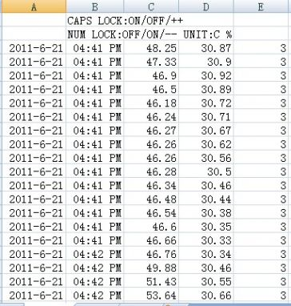

4. INSTALLING INSTRUCTION

Software installing instruction: please go to our website to download the process
a) Install dotnetfx.exe, if your computer system is Vista, may be you don’t need to install this process. Dotnetfx.exe is framework 2.0 of Microsoft; you can download it from the website of Microsoft;
b) Decompress TEMPerHUM V22.2.rar to you computer, and running TEMPerHUM V22.2.exe.
Hardware installing:
Plug the Hygrometer into the USB port of the computer to connect it. If you plug it correctly the red light in the device will be turned on.
5. Operating instruction (Note: Our software just only support windows system .)
1) THE TEMPERATURE & HUMIDITY DISPLAY BOX and MESSAGE FRAME

The Real Time Temperature and humidity will Display in the Box on the Top Left Corner of software interface and the Action of Operation will Display on the Top Right Corner (see picture1).
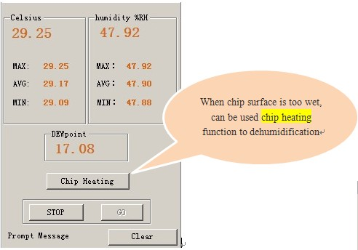

Picture 1 TEMPerHUM_Real time temperature
2) CURVES DISPLAY
There is Two Curves, One is AVG Line and the Other is Current Line. The User can Check the Situation of Temperature and humidity Contrastively. The Curves can Real-time Display the Changing Situation of Temperature and humidity . The Tendency of Curves Responds the Real-time Temperature and humidity Situation. (see picture2)
ADVISE: Please Check the Log or Data File in Save Contents When You Want to Check the Historical Data.
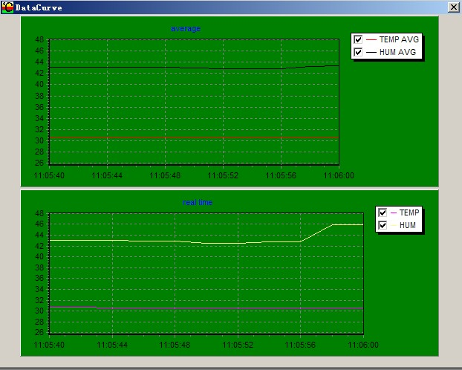
Picture 2 TEMPerHUM_Curve
3) LOG
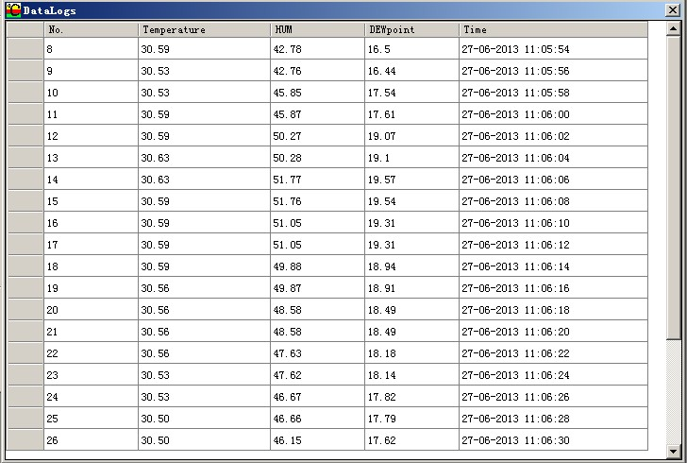
Picture 3 TEMPerHUM_Log .exe
4) MSN remote access to the temperature
After the MSN User Log in, His Friends can Operate by Related Tips and Obtain the Temperature Data and the humidity data. Your Friends can obtain the Temperature Data and humidity data Automatically When He Send “1”in According with Tips. The Temperature Data Including: Real-time Temperature, Maximum Value, Minimum Value and Average Value. The humidity Data including :Real-time humidity,Maximum Value Minimum Value and Average Value. (see picture 4)
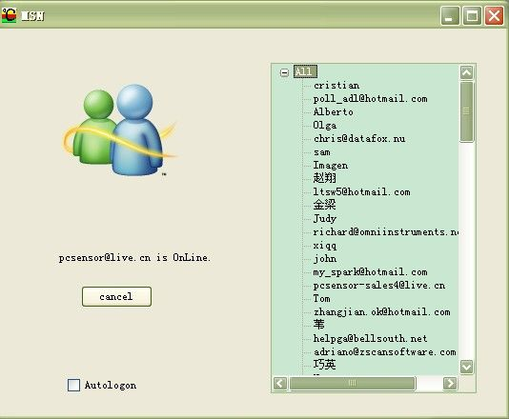
Picture 4 TEMPerHUM_MSN
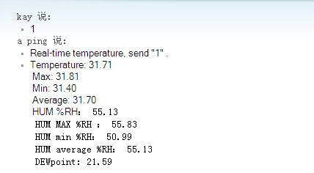
Picture 4 TEMPerHUM_MSN
5) Skype remote access to the temperature
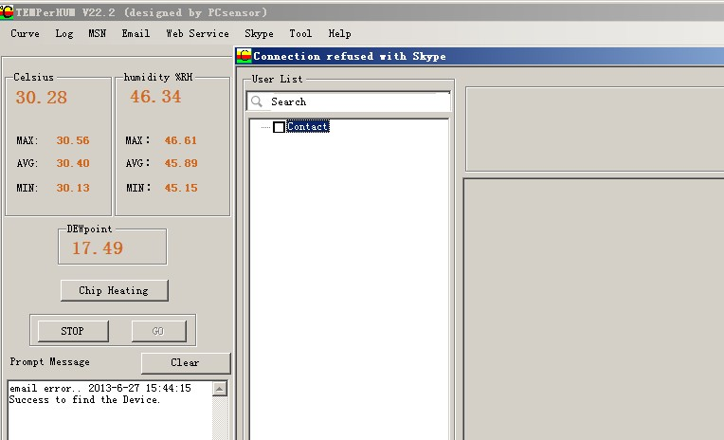
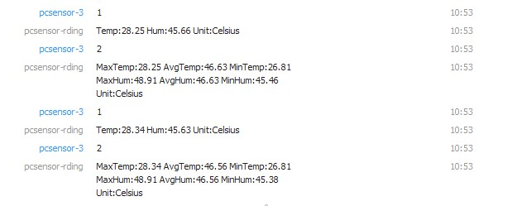
5) EMAIL FUNCTION

Fill in the Related Information of Email and Save it. The Requirement of Send Email: Support POP3/SMTP and Other Server Port. Receive Email you can fill in two.
Related Function: 1) when the Alarm is on, it will send the Email to Specified Email Box Automatically if the Temperature or humidity Reach the Alarm Limit. 2) You can set the Sending Interval, and then it will send the Email to the Specified Mail Box at Set Intervals. (Advise) 3) it can Send Email Continuously to the Specified Mail Box. (Deprecated feature) (See picture )
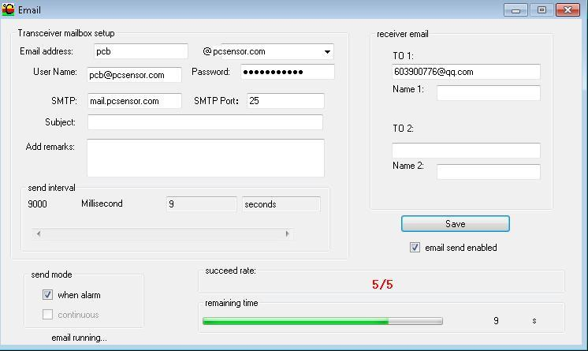
Picture 4 TEMPerHUM_Email
6) THE SAVING SETTING OF FILE

Select “Tool->Option->Memory Setting” then you can Set the Saving File Catalog, File Type and the Maximum Record Count the File can Save. (see picture5)
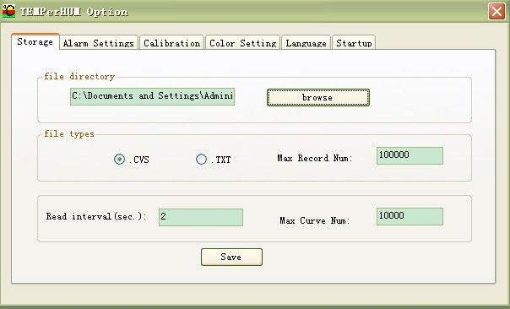
Picture 5 TEMPerHUM_Storage
7) THE ALARM SETTING

Set the Temperature of Alarm or the humidity of alarm and Open it. When the Temperature or humidity Reach the Higher Limit, the Voice of Alarm will Play, and it will Stop when the Temperature or humidity Drop to the Lower Limit.
Select “Toll->Select->Alarm” (see picture 6)
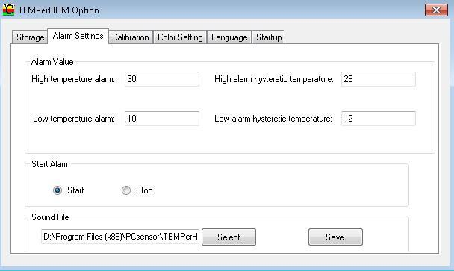
Picture6 TEMPerHUM_ Alarm setting
8) TEMPERATURE CORRECTION and UNIT SELECTION

When a Small Deviation occurs between the Displaying Temperature or humidity and the Actual Temperature or humidity , you can correct it through this Function. And you can select the unit of the temperature or humidity . (See picture 7)
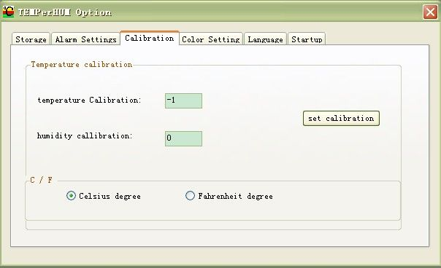
Picture7 TEMPerHUM_Calibration
9) CHANGE THE COLOR OF BACKGROUD

Select “Tool->Select->Color Setting”, Click Color Frame or Button to Choose the Color you Like (see picture8)
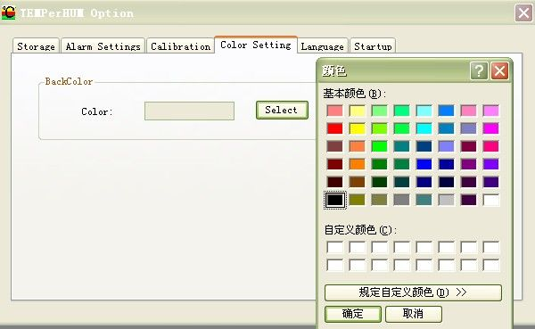
Picture8 TEMPerHUM_Color setting
10) CHANGE LANGUAGE

Select “Tool->Select->Language, then Choose English or Chinese” (see picture 9)
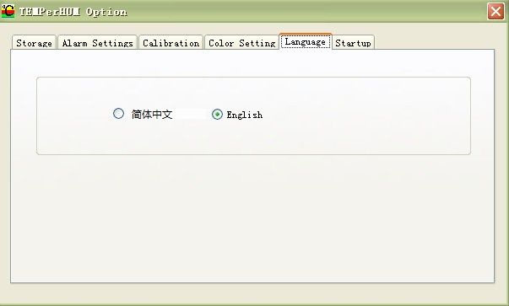
Picture9 TEMPerHUM_Language
11) HELP
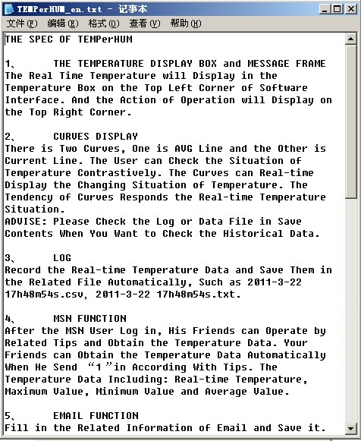
Picture10 TEMPerHUM_Help
12) ABOUT
You can see the vision of the software here, and if the vision is not the latest one, you can go to our website to download the latest one. That can make the device work better.
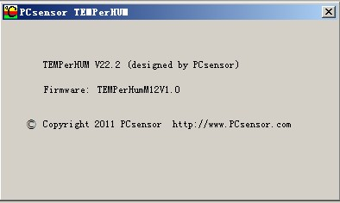

Picture11 TEMPerHUM_About

