 Saiyu Precision Stepper Motor Temp Gauge
賽宇 高精準 步進馬達 溫度表

●Super High Precision ● Stepper Motor Movement ● Most Advanced Technology ● Cool Design Style

超高精準度 ● 步進馬達機芯 ● 儀表最新科技導入 ● 冷冽時尚感設計

Peak value record auto replay function
峰值 紀錄/自動讀取 功能

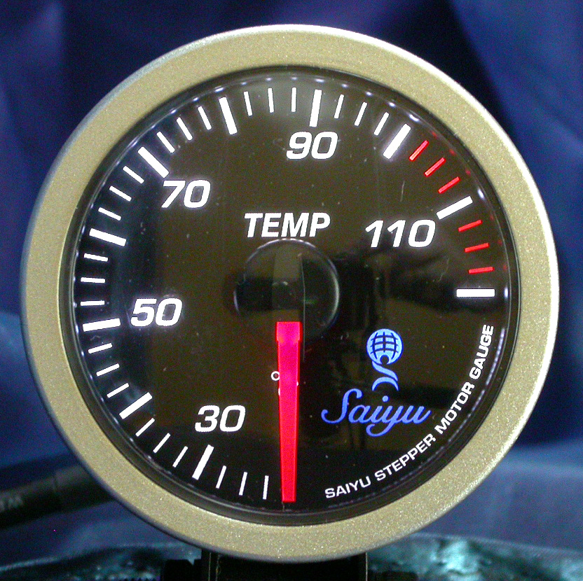

》High precision/full angle stepper motor used by the core.
》High-precision sensor
》Gauge Tube (52mm) / Max. panel (58mm)
》Super thin cylinder (40mm) design
》ON/OFF self-sweeping inspection function
》Peak value record auto replay function.
》Self-illumination/High Contrast/Optical Panel Lighting design
》Use high-illumination/longer life LED Light Source

*機芯採用高精準全角度步進馬達
*採用高精準感應器
*筒身直徑(52mm)/最大面板(58mm)
*超薄筒身(40mm)設計
*開關機自我掃描檢測
*峰值 紀錄/自動讀取 功能 *自發光/高反差/光學表盤 照明設計
*高亮度/長壽命 LED 光源採用

